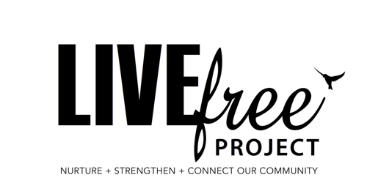

Date:

Employee Name:
Employee Role:

I hereby confirm that I have read and understand the policies and procedures of LIVEfree PROJECT INCORORPORATED.

I have been instructed that these are living documents and the latest copy of this document can be found at www.livefreeproject.org.au/hr . As these policies and procedures are updated as the law requires, I will ensure that I adjust the care of myself and care of others accordingly to comply with the legal requirements outlined in this document.

I have also been made aware that there is a copy kept in our office area available to look at any time.

If in doubt of any policy or procedure requirement and want or need further clarification, I can talk to my supervisor who will give clarity on next steps, or any areas of needed for clarification.

The name of my supervisor is: Rachel Gaunt
Role: Program Coordinator
M: 0402 362 177

I hear by state that the above has been explained to me and I understand the need to operate within the guidelines that the LIVEfree PROJECT policies and procedures outline.

Signature: ____________________________________

Name: _______________________________________

Date: ________________________________________

