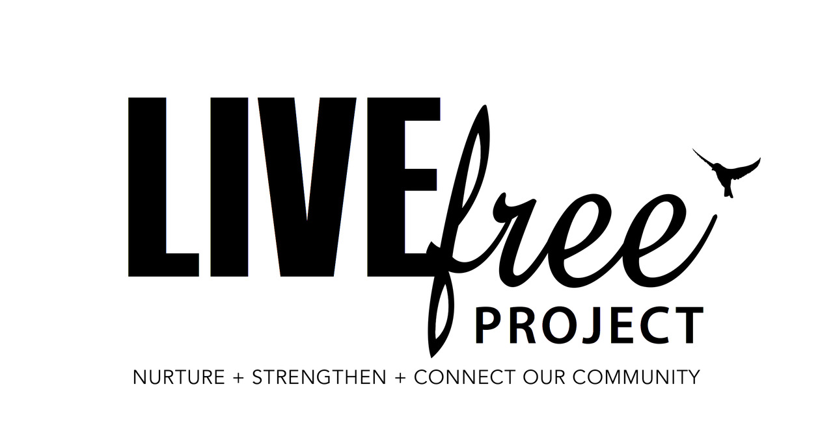

ACCESS & EQUITY
DIVERSITY & INCLUSION POLICY

Access, Equity, Diversity and Inclusion
LIVEfree PROJECT is committed to meeting the needs of individuals and families within the community, through the integration of access, equity, diversity and inclusion guidelines.
LIVEfree PROJECT will uphold equity principles for ALL, regardless of
- Race
- Culture
- Gender identity
- Age
- Social background
- Educational background
- Disability
- Sexual orientation
LIVEfree PROJECT will ensure the pillars of Diversity and Inclusion are upheld within the programs, client interaction and across all areas of community planning and engagement.
- Access: We will foster a welcoming environment and engage habits that create and maintain this within our organization and community.
- Attitude: We will be willing to action and implement changes to ensure access, equity, diversity and inclusion are embraced and we will be intentional in demonstrating this in meaningful ways to others through our attitude.
- Choice: We will ensure that clients are provided with autonomy of choice within their programs and support in connection with LIVEfree PROJECT to strive for inclusion and acceptance of others and their preferences.
- Partnerships: As we strengthen our reach into the community, we will be mindful in our associations with others, ensuring our embrace of others is inclusive and diverse.
- Communication: We will communicate in ways that influence inclusion in the communicative expression of the values, mission, and vision of LIVEfree PROJECT and all associated programs and engagements within community.
- Policy: We will ensure that our policies are inclusive, welcome diversity and adhere to the polices that work to guard and protect this stance of inclusivity and diversity.
- Opportunities: We will explore the options that are available for people from disadvantaged backgrounds.
All guidelines and programs are implemented through fair allocation of resources and the right to equality of opportunity without discrimination, being mindful of the strength that comes with diversity and the benefits of inclusion within community.

