10 PRODUCTIVITY TIPS FOR WORKING FROM HOME

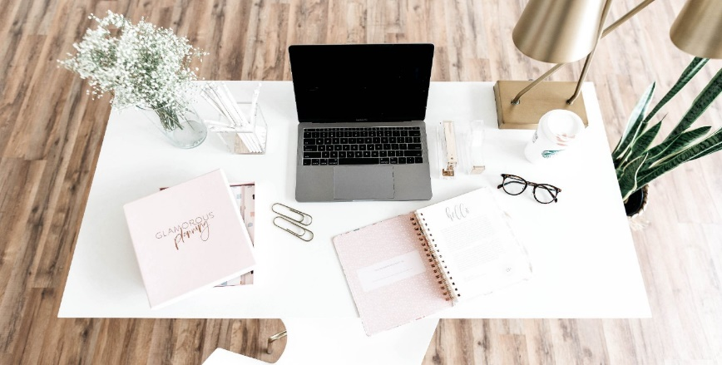
Especially During COVID-19

Depending on if you work for yourself or have a remote job, your schedule could be completely flexible or as rigid as a 9-5. Maybe you’ve been blessed with 1 day a week of working remotely, or maybe you’ve found yourself working from home because of certain situations (ahem, COVID-19).
Whatever your reason for working from home, you need to have some serious self-discipline and willpower to make it work. Here are my top 10 working from home productivity tips.
P.S. Most of these tips will apply to you even if you don’t work from home –
- STICK TO A SCHEDULE

I always liked the idea of working from home instead of the rigidity of being in an office from 9-5. Those hours seem so arbitrary, and it’s silly to think we can be productive for 8 hours straight. That being said, I’ve found that sticking to regular hours does make it easier to regulate my work. Of course, I have the freedom to throw the laundry on while I’m working or make a trip to the grocery store, but regular work hours help me to get more done. I recommend starting and ending work at a similar time each day. You don’t have to be at your computer at 9 am sharp, but you’re still responsible for getting your work done on time.

- MAKE TIME FOR YOURSELF BEFORE AND AFTER WORK

It’s easy to roll out of bed and head straight to your desk in the morning or work right up until bedtime. Since you’ve been blessed with no commute, make the most of the extra time you have. Do something for yourself like going for a walk, working out, making a hot breakfast, meditating, or reading a book. If there’s one thing you’ve always wished you could do before or after work, try adding it into your schedule. This will ensure that your work doesn’t take over your entire day.

- GET READY

With no one to judge you for your clothing choices, you might end up working from your PJs all day. This is fun to do sometimes, but you might feel lazy after a few days of living in dirty sweats. A lot of the time I do wear leggings (which feel like a step up from pajama pants), but I do find that putting on an actual outfit and doing my makeup makes me more productive. The plus side of doing this is that you’ll be ready to go if you have an unexpected video call or have to run an errand.

- DON’T WATCH TV UNLESS YOU’RE DOING MUNDANE TASKS

It can be tempting to work with Netflix playing in the background, but I’ve found this distracts me more than anything. There’s really no way to focus on both your work and the show, so try not to put your favorite show on unless you’re doing tasks that don’t require much mental effort.

- CREATE A PRODUCTIVE ATMOSPHERE

Though I don’t recommend watching TV while you work, I do recommend a few YouTube videos that help create a calming working atmosphere. Here are some of my favorites:
Lofi Hip Hop Radio – Super chill music with no distracting lyrics | Coffee Shop Ambiance – if you miss having people around, this one will make you feel like you’re actually at a coffee shop | Ancient Library room – the thunder and rain sounds from this one are super comforting.
- GET IMPORTANT TASKS DONE IN SOLITUDE

If you’re around others when you’re working from home, get your most important tasks done in a quiet space by yourself. I personally enjoy having other people around when I’m doing mundane tasks, but I need my focus and quiet time to get the important things done. Some people think working from home is more distracting than an office, but I used to work in an open office where I could hear other people’s conversions, phone calls, and meetings all day long. This taught me to go into another room or listen to music to block out the distractions when I need to focus.

- TRACK YOUR TIME

If you struggle to be productive at home (or in general), try tracking your time with something like Toggl. Tracking my time has helped me realize when I’m spending too much time on useless tasks. My personal distractions involve dancing around the living room, watching the ducks outside my window, and organizing my closet. When I time how long these things take, I realize how much they’re taking away from my work time. Tracking your time can open your eyes to your procrastination habits. An added bonus is that it can encourage you to be MORE productive because you feel like you’re being watched by the clock.

- SWITCH UP YOUR ENVIRONMENT

There are some people who can only work from their desk, but I am not one of those people. I have to switch things up to keep myself motivated and inspired. Though I have a designated desk space in my apartment, I’ve found myself working from the couch, the kitchen table, the bedroom floor, standing at the kitchen island, and (unashamedly) from bed. Sometimes I have to work from a coffee shop because having people around makes me procrastinate less. The point is that switching things up keeps things interesting, and working from home gives you the luxury of doing this. Even with a small space, you can try different set-ups to boost your productivity.

- MIND YOUR FOOD HABITS

Eat lunch at a normal time and try to eat your meals away from your workspace. I’ve also found that prepping meals ahead of time is also super helpful. Even though I can make my lunch at home, most of the time I don’t want to spend much time cooking at lunchtime. Having something made ahead of time makes life a lot easier. And let’s not forget snacks. It’s really tempting to snack all day when you have access to the pantry, but try sticking to a snack schedule if this is something you struggle with. For example, I pretty much always take a break around 2:45 for a snack.

- REMEMBER TO TAKE BREAKS

When you don’t have a designated lunch break, it’s easy to stay glued to your desk for 8 hours straight. Try working in 30-50 minute increments and take a break afterward (use a timer to remind you). Step outside for some fresh air. Do a few quick stretches. Get up and go for a walk. Text or call another human being if you feel isolated from others. You don’t want your work from home life to burn you out, so make it a priority to take regular breaks.

